**rpWtu; cupik tpopg;Gzu;T epfo;T mwp;f;if**

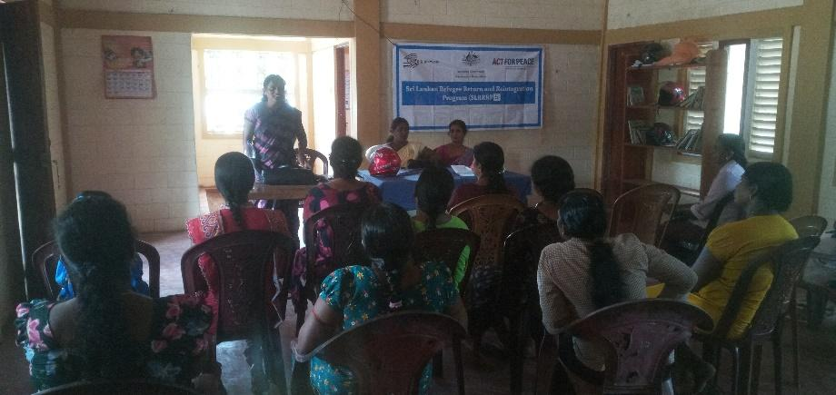

nraw;wpl;lk; - SLRRRP 5

jpfjp – 19.04.2024

,lk; - cjaefu; Nkw;F> fpspnehr;rp

Neuk; - fhiy 10.00 kzp

gq;Fgw;wpNahu; - 44 Ngu;

rpWtu; cupik kw;Wk; ghJfhg;G njhlu;ghd tpopg;Gzu;T epfo;thdJ cjaefu; Nkw;F fpuhk mYtyu; gpuptpy; ,lk;ngw;wJ. ,jpy; tsthsuhf nry;tp epUgh fiur;rp gpuNjr nrayf rpWtu; mgptpUj;jp cj;jpNahfj;ju; mtu;fs; fye;J nfhz;lhu;. xgu; gzpahsu; gfpu;jh mtu;fs; epfo;T njhlu;ghfTk; SLRRRP nraw;ghLfs; Fwpj;Jk; mwpKf ciu toq;fpdhu;. gpd;G cjaefu; Nkw;F fpuhk mYtyu; ciu toq;fpdhu;. ,jpy; jw;Nghija #oypy; ,lk;ngWk; rpWtu; gpur;ridfs; Fwpj;Jk; mtw;wpypUe;J rpWtu;fis ghJfhg;gJ Fwpj;Jk; fUj;J toq;fpdhu;. njhlu;e;J tsthsu; ciu ,lk;ngw;wJ. mjpy; rpWtu; cupik vd;why; vd;d vd tpdtg;gl;lJ. njhlu;e;J rpWtu; cupik vd;why; vd;d> rpwe;j gps;is tsu;g;G vt;thW mika Ntz;Lk;> rpWtu; ghJfhg;G kw;Wk; kfpo;r;rpahd FLk;gk; Nghd;w Kf;fpa jiyg;Gf;fspy; fUj;Jf;fs; gfpug;gl;lJ.

mjpy; gps;isfis ghlrhiyf;F mDg;Gtjd; Nehf;fk; vd;dntd tpdhtpdhu;. mjw;F ngw;Nwhu;

* ey;y kdpju;fshf tho
* Kd;khjpupif kpf;f gps;isfshf tho
* Nkw;gbg;G gbf;f Ntz;Lk; vd;w fhuzj;jpdhy; 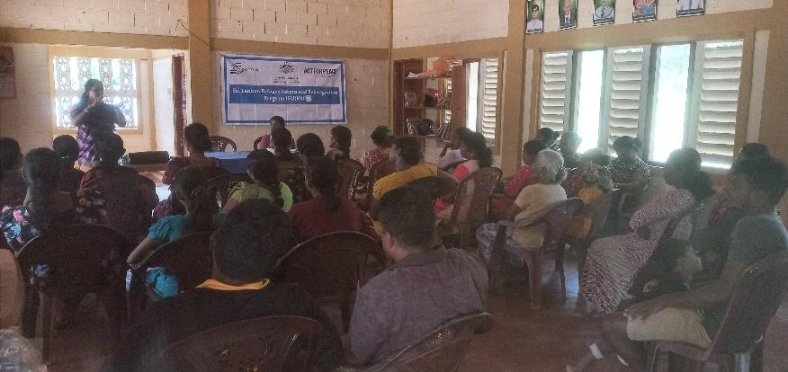
* mur jdpahu; Jiwfspy; gq;Fgw;w Ntz;Lk; vDk; Nehf;fq;fSf;fhf

gps;isfis ghlrhiyf;F mDg;GtjhfTk; ngw;Nwhu; $wpdu;.

vy;yh gps;isfSk; ghlrhiyf;F Nghfpwhu;fsh? vdf; Nfl;lhy; ,y;iy. Vndd;why; rpy khztu;fs; xOq;fhf ghlrhiy nry;tjpy;iy. ghlrhiy ,iltpyfy; khztu;fs; njhlu;ghf fye;Jiuahlg;gl;lJ.

khztu;fs; rpyupd; fy;tp eltbf;iffs; xOf;fkpd;ikahfTk;>Vida khztu;fis Fog;Gk; nraw;ghlhfTk;> fy;tpapy; Mu;tkpd;ikAk; mtu;fspd; fy;tp nraw;ghl;ilAk; Vida khztiuAk; ghjpf;fpd;wJ. njhlu;e;J ,t;thW guPl;irapy; Njhy;tpAWk; khztu;fis topg;gLj;jp njhopy; tha;g;Gf;fis ngw;Wf;nfhLg;gJ ngw;Nwhupd; flikahFk; vd njspTgLj;jg;gl;lJ. njhopy; tha;g;Gf;fs; njhlu;ghf mjhtJ nghwpapayhsu;>kUj;Jtu;>jr;rd;>Nkrd; vd Kf;fpa njhopy; Jiwfs; xt;nthd;iwAk; gw;wpAk; mj;Jiwfspy; vt;thW Kd;Ndwyhk; Nghd;w tplaq;fSk; $wg;gl;lJ.

njhopw;fy;tp mjhtJ 13 tUl fy;tpj;jpl;lk; NAITA Nghd;w fy;Y}upfspy; gps;isfis ,izj;J fw;f itf;fyhk;. NkYk; Hotel Management fw;wy; ,J ey;y rk;gsj;ij toq;Ffpd;wJ. ,J rhu;e;j Level – 05 fw;wiy University,Collage toq;Ffpd;wJ. mjpy; khztu;fs; ,ize;J fw;f ngw;Nwhu; topg;gLj;j Ntz;Lk;. vdTk; $wpdhu;.

gpd;du; gps;isfspd; fw;wy; eltbf;iffs; njhlu;ghf ngw;Nwhuplk; tpdtg;gl;lJ.

* gps;isfs; rpyNtisfspy; jhkhf gbg;ghu;fs; rpyNtisfspy; mtu;fis fl;lhag;gLj;jp gbg;gpf;f Ntz;bAs;sJ.
* ehk; gps;isfspd; fy;tpapy; mf;fiwNahL nraw;gLfpNwhk;.
* vkf;F gps;isfs; ey;y epiyia mila Ntz;Lk; vd;gNj Mir

Nghd;w fUj;Jf;fisAk; ngw;Nwhu; $wpdhu;fs;.

“,d;iwa rpWtu;fNs ehisa jiytu;fs;” vd;w $w;Wf;fpzq;f mtu;fSf;F rl;lj;jpd; %yk; xspkakhd vjpu;fhyj;ij ngw;Wf; nfhLg;gjw;fhd #o;epiyfis Vw;gLj;jpf; nfhLg;gJ midtuJ flikAkhFk;. MfNt rpWtu; njhlu;;ghf mjpf ftdnkLj;J nraw;gl Ntz;Lk; vdTk; njuptpf;fg;gl;lJ. gpd;G gfpu;jh mtu;fspd; ed;wpAiuNahL rpWtu; cupik njhlu;ghd tpopg;Gzu;T epfo;thdJ epiwT ngw;wJ.

njhFg;G 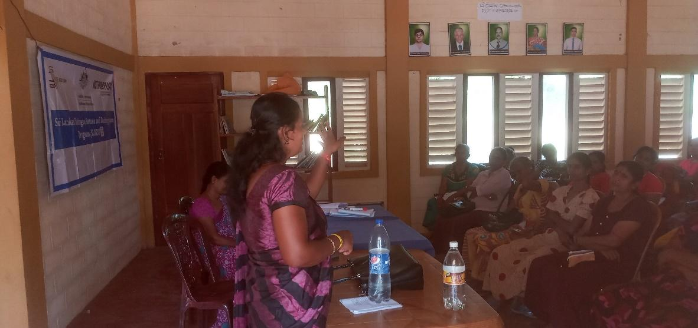

Qh.gfpu;jh